

Semester Two Examination, 2022
Question/Answer booklet

MATHEMATICS
SPECIALIST
UNITS 3&4

SOLUTIONS
Section One:
Calculator-free
WA student number: In figures

In words

Your name

Number of additional
answer booklets used
(if applicable):

Time allowed for this section
Reading time before commencing work: five minutes
Working time: fifty minutes

Materials required/recommended for this section
To be provided by the supervisor
This Question/Answer booklet
Formula sheet

To be provided by the candidate
Standard items: pens (blue/black preferred), pencils (including coloured), sharpener,
correction fluid/tape, eraser, ruler, highlighters

Special items: nil

Important note to candidates
No other items may be taken into the examination room. It is your responsibility to ensure that you do not have any unauthorised material. If you have any unauthorised material with you, hand it to the supervisor before reading any further.

Structure of this paper

Section | Number of  questions  available | Number of  questions to  be answered | Working  time  (minutes) | Marks  available | Percentage  of  examination
Section One:  Calculator-free | 7 | 7 | 50 | 49 | 35
Section Two:  Calculator-assumed | 12 | 12 | 100 | 91 | 65
 |  |  |  | Total | 100

Instructions to candidates

1. The rules for the conduct of examinations are detailed in the school handbook. Sitting this examination implies that you agree to abide by these rules.

2. Write your answers in this Question/Answer booklet preferably using a blue/black pen.
Do not use erasable or gel pens.

3. You must be careful to confine your answers to the specific question asked and to follow any instructions that are specific to a particular question.

4. Show all your working clearly. Your working should be in sufficient detail to allow your answers to be checked readily and for marks to be awarded for reasoning. Incorrect answers given without supporting reasoning cannot be allocated any marks. For any question or part question worth more than two marks, valid working or justification is required to receive full marks. If you repeat any question, ensure that you cancel the answer you do not wish to have marked.

5. It is recommended that you do not use pencil, except in diagrams.

6. Supplementary pages for planning/continuing your answers to questions are provided at the end of this Question/Answer booklet. If you use these pages to continue an answer, indicate at the original answer where the answer is continued, i.e. give the page number.

7. The Formula sheet is not to be handed in with your Question/Answer booklet.
Section One: Calculator-free 35% (49 Marks)
This section has seven questions. Answer all questions. Write your answers in the spaces provided.

Working time: 50 minutes.

Question 1 (6 marks)
The point $P(0, -0.5)$ and part of the slope field given by $\begin{matrix}dy \\ \overline{\overset{ }{dx}}\end{matrix}=y^{2}\sin^{2}{x}$ is shown below.
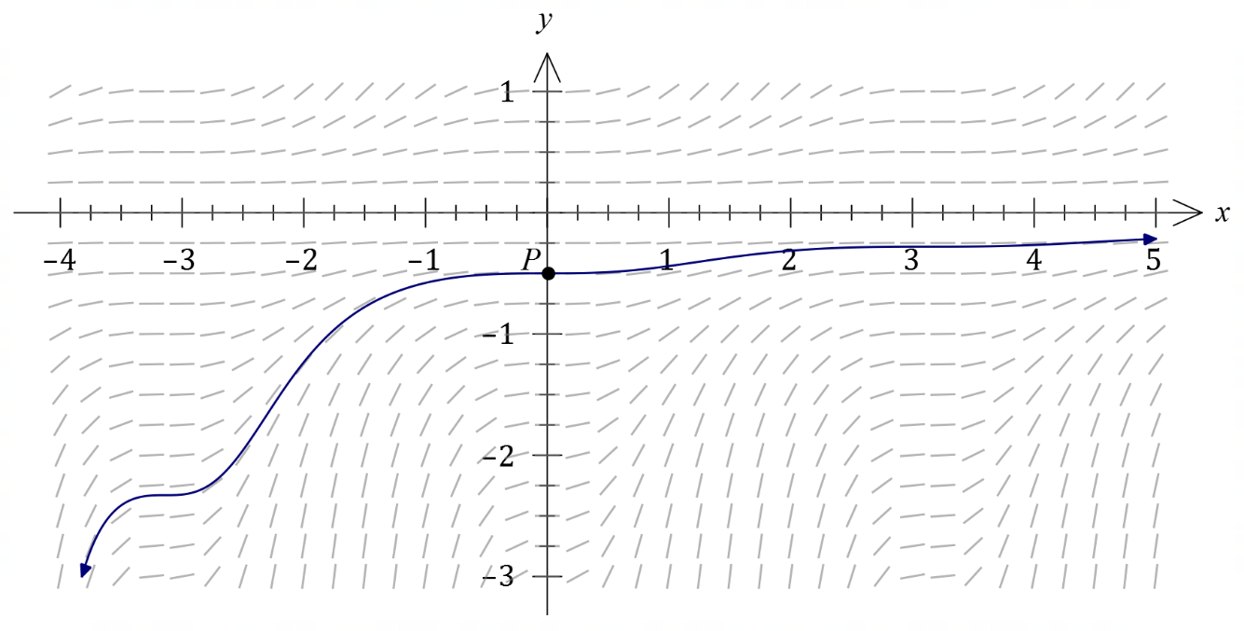

(a) Determine the equation of the solution curve through $P$ in the form $y=f(x)$. (4 marks)
Solution
$$\int{y^{-2}}dy=\int{\sin^{2}{x}}dx$$

$$\int{y^{-2}}dy=\int{\frac{1}{2}\left(1-\cos{2x}\right)}dx$$

$$-\frac{1}{y}=\frac{1}{2}x-\frac{1}{4}\sin{2x}+c$$

$$P\left(0, -0.5\right)⇒c=2$$

$$y=-\frac{1}{\frac{1}{2}x-\frac{1}{4}\sin{2x}+2}=\frac{4}{\sin{2x}-2x-8}$$

Specific behaviours
separates variables as an integration statement
ü correctly uses trig identity on RHS
ü correctly obtains antiderivative, with constant
ü evaluates constant and writes in required form

(b) Draw the solution curve through $P$ on the slope field above. (2 marks)
Solution
See slope field
Specific behaviours
curve to left of $y$-axis has two inflection points and follows slope field
ü curve to right of $y$-axis has two inflection points and follows slope field

Question 2 (7 marks)
Let $f\left(x\right)=\begin{matrix}(x+1)(3-x) \\ \overline{ \overset{ }{2} }\end{matrix}$.

(a) Sketch the graph of $y=f(x)$. (1 mark)
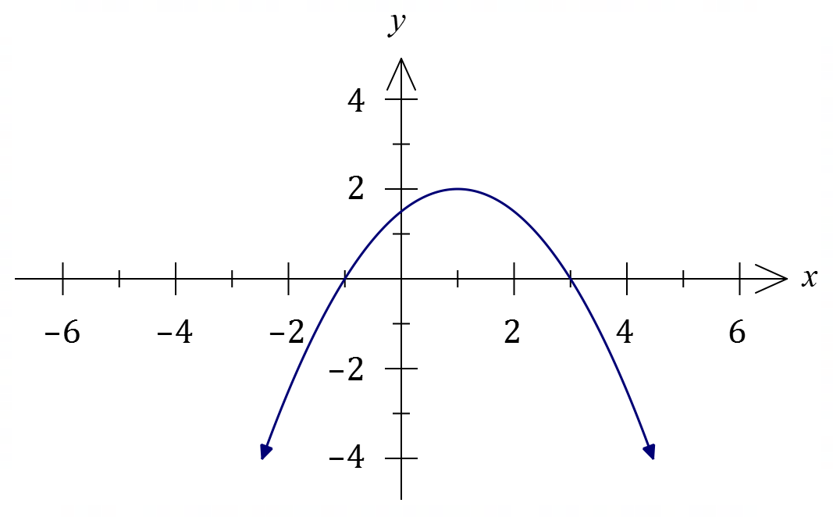
Solution
See graph
Specific behaviours
reasonable sketch

(b) On the axes below, sketch the graph of $y=|f\left(\left|x\right|\right)|$. (2 marks)

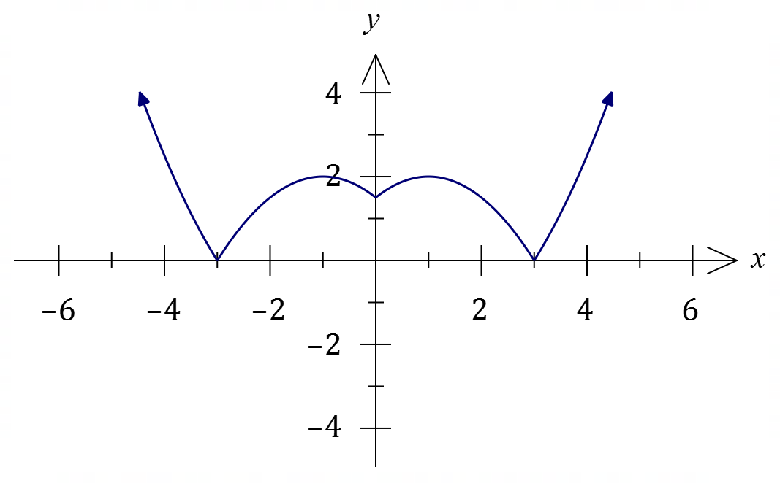
Solution
See graph
Specific behaviours
symmetry about $y$-axis
ü correct sketch

Consider $g(x)=\begin{matrix}2 \\ \overline{3+2x-x^{2}}\end{matrix}$.

(c) Briefly describe how the graph of $y=f(x)$ can be used to sketch the graph of $y=g(x)$ and hence state the domain and range of $g(x)$. (4 marks)
Solution
The graph of $y=g(x)$ is the same as the graph of $y=\begin{matrix}1 \\ \overline{f(x)}\end{matrix}$.

Domain $D_{g}=\left\{x \right| x∈R, x≠-1, x≠3\}$.

Range $R_{g}=\left\{y | y∈R, y<0∪y≥\frac{1}{2}\right\}$.

Specific behaviours
explains $g(x)$ is reciprocal of $f(x)$
ü correct restrictions on $x$ for domain
ü states $y<0$ component of range
ü states $y≥\frac{1}{2}$ component of range

Question 3 (8 marks)
The equations of planes $Π_{1}, Π_{2}$ and $Π_{3}$ are shown below.

$$\begin{matrix}Π_{1} & Π_{2} & Π_{3} \\ r=\left(\begin{matrix}2 \\ 5 \\ 3\end{matrix}\right)+λ\left(\begin{matrix}-1 \\ 3 \\ 1\end{matrix}\right)+μ\left(\begin{matrix}2 \\ -1 \\ 3\end{matrix}\right) & r∙\left(\begin{matrix}2 \\ 1 \\ 2\end{matrix}\right)=18 & x-y+z=15\end{matrix}$$

(a) Show that the equation of plane $Π_{1}$ in Cartesian form is $2x+y-z=6$. (3 marks)
Solution
Cross product of vectors in plane is $a=\left(\begin{matrix}-1 \\ 3 \\ 1\end{matrix}\right)×\left(\begin{matrix}2 \\ -1 \\ 3\end{matrix}\right)=\left(\begin{matrix}10 \\ 5 \\ -5\end{matrix}\right)$.
Let normal to plane be $n=\frac{1}{5}a=\left(\begin{matrix}2 \\ 1 \\ -1\end{matrix}\right)$, so that $\left(\begin{matrix}x \\ y \\ z\end{matrix}\right)∙\left(\begin{matrix}2 \\ 1 \\ -1\end{matrix}\right)=\left(\begin{matrix}2 \\ 5 \\ 3\end{matrix}\right)∙\left(\begin{matrix}2 \\ 1 \\ -1\end{matrix}\right)=4+5-3=6$.

Hence Cartesian equation is $2x+y-z=6$.

Specific behaviours
writes cross product of two vectors that lie in $Π_{1}$
ü obtains normal to plane
ü uses vector equation $r∙n=a∙n$ to derive Cartesian equation

(b) The origin lies on the surface of sphere $S$. Determine the vector equation of $S$, given that its centre is the point of intersection of the three planes. (5 marks)
Solution
$$2x+y-z=6 \\ 2x+y+2z=18 \\ x-y+z=15$$

Subtracting first from middle gives $3z=12⇒z=4$.
Adding first to last gives $3x=21⇒x=7$.
Hence $y=7+4-15=-4$ and so intersect at $(7, -4, 4)$.

Distance from centre of $S$ to $O$ is $\sqrt{7^{2}+4^{2}+4^{2}}=9$.

Hence equation of $S$ is $\left|r-\left(\begin{matrix}7 \\ -4 \\ 4\end{matrix}\right)\right|=9$.

Specific behaviours
writes system of equations, correctly starts elimination
ü solves for one variable
ü solves for all variables
ü determines distance from origin
ü correctly writes equation of sphere

Question 4 (6 marks)
Let $f\left(z\right)=3z^{3}+pz^{2}+16z+q$, where $p$ and $q$ are real constants.

One of the roots of $f\left(z\right)$ is $z=1+\sqrt{3}i$.

(a) Determine the value of the constant $p$ and the value of the constant $q$. (4 marks)
Solution
Product of factors using given root and conjugate:
$$\left(z-\left(1+\sqrt{3}i\right)\right)\left(z-\left(1-\sqrt{3}i\right)\right)=z^{2}-2z+4$$
Hence
$$f\left(z\right)=3z^{3}+az^{2}+16z+b=\left(z^{2}-2z+4\right)\left(3z+k\right)$$Comparing $z$ coefficients:
$$16=12-2k⇒k=-2$$

Hence from expansion of factors, $p=k-6=-8$ and $q=4k=-8$.

$$p=q=-8$$

Specific behaviours
indicates conjugate is another root
ü obtains quadratic factor of $f(x)$
ü uses quadratic factor to obtain linear factor
ü states correct values for $p$ and $q$

(b) Show all the roots of $f\left(z\right)$ in the complex plane below. (2 marks)

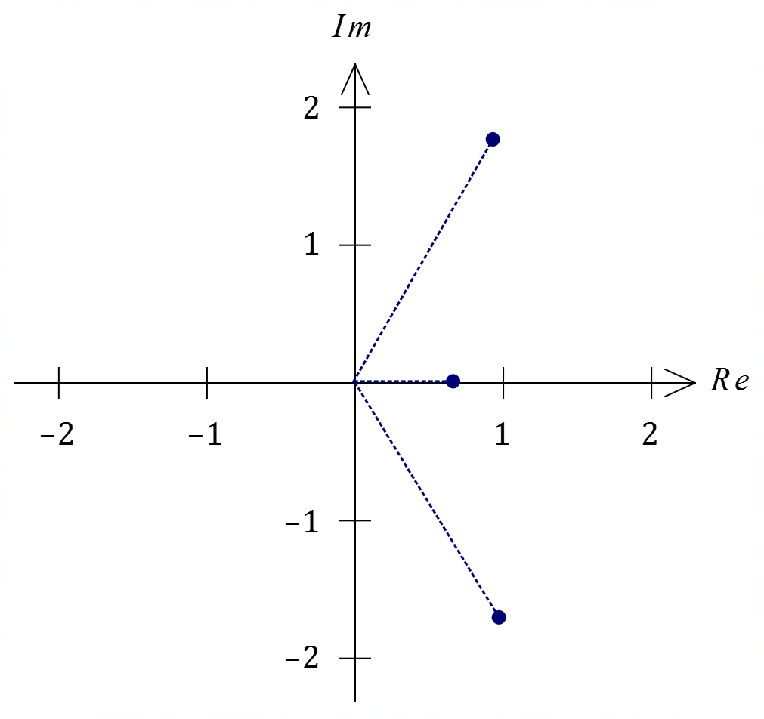
Solution
See diagram
Specific behaviours
shows given root and conjugate
ü shows real root

Question 5 (7 marks)
An electronic circuit will remain stable when $x$ and $y$, the resistances in ohms of two variable resistors in the circuit, satisfy
$$\frac{3}{x}+\frac{5}{y}=\frac{1}{10}.$$

(a) When $y$ is decreasing at a rate of $5$ ohms per second, determine the rate that $x$ must be changing for the circuit to remain stable when $y=200$ ohms. (4 marks)
Solution
Require $\begin{matrix}dx \\ \overline{dt}\end{matrix}$ given $\begin{matrix}dy \\ \overline{dt}\end{matrix}=-5$, so implicitly differentiate wrt $t$:

$$-\frac{3}{x^{2}}\frac{dx}{dt} -\frac{5}{y^{2}}\frac{dy}{dt}=0⇒\frac{dx}{dt}=-\frac{5x^{2}}{3y^{2}}\frac{dy}{dt}$$

$$\frac{3}{x}+\frac{5}{200}=\frac{1}{10}→\frac{3}{x}=\frac{2}{20}-\frac{1}{20}→x=60$$

$$\frac{dx}{dt}=-\frac{5×60×60}{3×200×200}×-5=\frac{1}{3}$$

Hence $x$ must increase at $\begin{matrix}1 \\ \overline{3}\end{matrix}$ ohms per second for stability.

Specific behaviours
implicitly differentiates equation
ü obtains expression for $\dot{x}$
ü indicates correct values for $\dot{y}$ and $x$
ü correctly evaluates $\dot{x}$

(b) The circuit is stable, the resistance of $x$ is increasing at $6$ ohms per second and has just reached $60$ ohms. Use the technique of increments to calculate the approximate change in the resistance of $y$ in the next tenth of a second. (3 marks)
Solution
$$δt=0.1, \frac{3}{60}+\frac{5}{y}=\frac{1}{10}→\frac{5}{y}=\frac{2}{20}-\frac{1}{20}→y=100$$

$$δy≈\frac{dy}{dt}δx \\ =-\frac{3y^{2}}{5x^{2}}\frac{dx}{dt}δt \\ =-\frac{3×100×100}{5×60×60}×6×0.1 \\ =-1 \text{ohm}$$

Resistance of $y$ will decrease by $1$ ohm.

Specific behaviours
states correct values for $y$ and $δt$
ü forms correct expression for $δy$
ü correct value for $δy$

Question 6 (8 marks)
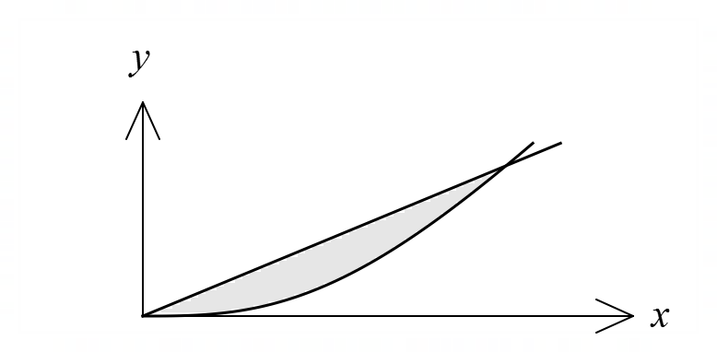
(a) The line $y=x$ and the curve $y=\begin{matrix}{2x}^{3} \\ \overline{x^{2}+4}\end{matrix}$ are
shown in the diagram. They intersect at the
origin and at $x=2$.
Determine the area between the curve and the
line in the first quadrant.

(5 marks)
Solution
To determine area under curve let $u=x^{2}+4$, so that $du=2x dx,$ $x=0→u=4$ and $x=2→u=8$. Then

$$\int_{0}^{2}{\frac{x^{2}}{x^{2}+4} 2x}dx=\int_{4}^{8}{\frac{u-4}{u}}du \\ =\int_{4}^{8}{1-\frac{4}{u}}du \\ ={\left[u-4\ln{u}\right]}_{4}^{8} \\ =\left(8-4\ln{8})-(4-4\ln{4}\right) \\ =4-4(\ln{8}-\ln{4})=4-4\ln{2}$$
Area under line is $\frac{1}{2}\left(2\right)\left(2\right)=2$.
Hence area between is $2-\left(4-4\ln{2}\right)=4\ln\left(2\right)-2 \text{sq units}$.

Specific behaviours
chooses suitable substitution
ü writes integral in terms of $u$
ü obtains antiderivative
ü obtains area under curve
ü obtains area between

(b) Given that $\int_{2}^{8}{\underset{ }{\overset{ }{\begin{matrix}f(x) \\ \overline{ x^{2}}\end{matrix} }}}dx=6$, determine $\int_{1}^{4}{\underset{ }{\overset{ }{f\left(\begin{matrix}8 \\ \overline{\overset{ }{x}}\end{matrix}\right)}}}dx$. (3 marks)
Solution
Let $u=\begin{matrix}8 \\ \overline{\overset{ }{x}}\end{matrix}$, so that $x=\begin{matrix}8 \\ \overline{u}\end{matrix} , dx=-\begin{matrix}8 \\ \overline{u^{2}}\end{matrix} du$, $x=1→u=8$ and $x=4→u=2$.
Then
$$\int_{1}^{4}{f\left(\frac{8}{x}\right)}dx=\int_{8}^{2}{f\left(u\right)}\left(-\frac{8}{u^{2}}\right)du \\ =-(-8)\int_{2}^{8}{\frac{f\left(u\right)}{u^{2}}}du \\ =8×6=48$$

Specific behaviours
chooses substitution and relates $dx$ and $du$
ü writes integral in terms of $u$
ü derives correct value

Question 7 (7 marks)
(a) Determine the value of the constant $A$ and the value of the constant $B$ so that

$$\frac{5}{(3x-2)(x+1)}=\frac{A}{3x-2}+\frac{B}{x+1} .$$
(2 marks)
Solution
Combining RHS into single fraction and equating numerators:

$$Ax+A+3Bx-2B=5⇒A-2B=5, A+3B=0$$

Hence $A=3$ and $B=-1$.

Specific behaviours
indicates appropriate method
ü solves for $A, B$ correctly

(b) Hence use the substitution $u=\cos{x}$ to determine
$$\int{\frac{5\sin{x}}{2\cos{2x}-\cos^{2}{x}+\cos{x}}}dx.$$
(5 marks)
Solution
Simplify denominator
$$2\left(2\cos^{2}{x}-1\right)-\cos^{2}{x}+\cos{x}=3\cos^{2}{x}+\cos{x}-2 \\ =3u^{2}+u-2 \\ =(3u-2)(u+1)$$
Also
$$u=\cos{x}⇒du=-\sin{x}dx$$
Hence
$$\int{\frac{-5}{3\cos^{2}{x}+\cos{x}-2}}\left(-sin{x}\right)dx=\int{\frac{-5}{\left(3u-2\right)\left(u+1\right)}}du \\ =\int{\frac{1}{u+1}-\frac{3}{3u-2}}du \\ =\ln\left|u+1\right|-\ln\left|3u-2\right|+c \\ =\ln\left|\cos{x}+1\right|-\ln\left|3\cos{x}-2\right|+c \\ =\ln\left|\frac{\cos{x}+1}{3\cos{x}-2}\right|+c$$

Specific behaviours
simplifies denominator in terms of $\cos{x}$
ü correctly relates $dx$ and $du$
ü uses partial fractions to express integral in terms of $u$
ü obtains antiderivative with absolute value brackets
ü correct result in terms of $x$, and integration constant

Supplementary page

Question number: _________

© 2022 WA Exam Papers. Perth Modern School has a non-exclusive licence to copy and communicate this document for non-commercial, educational use within the school. No other copying, communication or use is permitted without the express written permission of WA Exam Papers. SN078-204-3.

